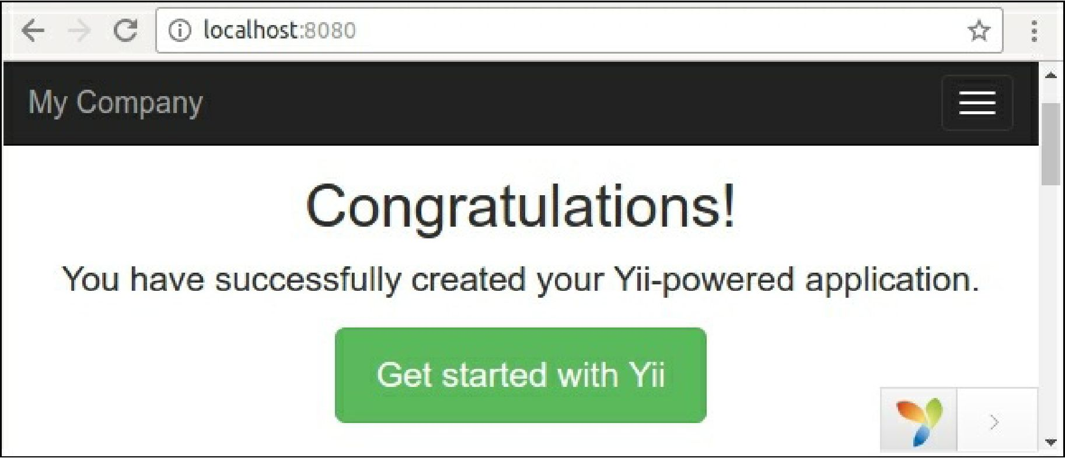

For permanent working create a new host in your server (Apache, Nginx, and so on) and set the web directory as a document root of the host.

**Installing advanced project template**

Carry out the following steps for installing advanced project template:

1. As the first step open your terminal install Bower-to-Composer adapter: composer global require "fxp/composer-asset-plugin:A1.2.0"

It provides a simple way to load related non-PHP packages (JavaScript and CSS) from the Bower repository.

2. Create a new application in the new basic directory:

composer create-project --prefer-dist yiisoft/yii2-app-advanced advanced

3. The new application does not contains local configuration files and index. php entry scripts yet. To generate the files just init a working environment:

cd advanced php init

During initialization select the Development environment.

4. Check that your PHP contains the required extensions:

php requirements.php

**Note**